**Exercise 1: Control Structures**

**DB Structure and Dummy Data :**

SET SERVEROUTPUT ON SIZE 1000000;

CREATE TABLE customers (

customer_id NUMBER PRIMARY KEY,

customer_name VARCHAR2(100) NOT NULL,

date_of_birth DATE NOT NULL,

balance NUMBER(15,2) DEFAULT 0,

is_vip CHAR(1) DEFAULT 'N' CHECK (is_vip IN ('Y', 'N')),

email VARCHAR2(100),

phone VARCHAR2(15),

created_date DATE DEFAULT SYSDATE

);

CREATE TABLE loans (

loan_id NUMBER PRIMARY KEY,

customer_id NUMBER NOT NULL,

loan_amount NUMBER(15,2) NOT NULL,

interest_rate NUMBER(5,2) NOT NULL,

loan_start_date DATE NOT NULL,

loan_due_date DATE NOT NULL,

loan_status VARCHAR2(20) DEFAULT 'ACTIVE',

CONSTRAINT fk_customer_loan FOREIGN KEY (customer_id) REFERENCES customers(customer_id)

);

CREATE SEQUENCE customer_seq START WITH 1 INCREMENT BY 1;

CREATE SEQUENCE loan_seq START WITH 1 INCREMENT BY 1;

INSERT INTO customers (customer_id, customer_name, date_of_birth, balance, email, phone) VALUES

(customer_seq.NEXTVAL, 'John Smith', DATE '1950-05-15', 15000.00, 'john.smith@email.com', '555-0101');

INSERT INTO customers (customer_id, customer_name, date_of_birth, balance, email, phone) VALUES

(customer_seq.NEXTVAL, 'Maria Garcia', DATE '1960-08-22', 8500.00, 'maria.garcia@email.com', '555-0102');

INSERT INTO customers (customer_id, customer_name, date_of_birth, balance, email, phone) VALUES

(customer_seq.NEXTVAL, 'Robert Johnson', DATE '1955-12-10', 25000.00, 'robert.johnson@email.com', '555-0103');

INSERT INTO customers (customer_id, customer_name, date_of_birth, balance, email, phone) VALUES

(customer_seq.NEXTVAL, 'Emily Davis', DATE '1985-03-18', 12000.00, 'emily.davis@email.com', '555-0104');

INSERT INTO customers (customer_id, customer_name, date_of_birth, balance, email, phone) VALUES

(customer_seq.NEXTVAL, 'Michael Wilson', DATE '1945-07-30', 5000.00, 'michael.wilson@email.com', '555-0105');

INSERT INTO customers (customer_id, customer_name, date_of_birth, balance, email, phone) VALUES

(customer_seq.NEXTVAL, 'Sarah Brown', DATE '1992-11-05', 7500.00, 'sarah.brown@email.com', '555-0106');

INSERT INTO loans (loan_id, customer_id, loan_amount, interest_rate, loan_start_date, loan_due_date) VALUES

(loan_seq.NEXTVAL, 1, 50000.00, 5.5, DATE '2024-01-15', SYSDATE + 20);

INSERT INTO loans (loan_id, customer_id, loan_amount, interest_rate, loan_start_date, loan_due_date) VALUES

(loan_seq.NEXTVAL, 2, 30000.00, 6.0, DATE '2024-03-10', SYSDATE + 15);

INSERT INTO loans (loan_id, customer_id, loan_amount, interest_rate, loan_start_date, loan_due_date) VALUES

(loan_seq.NEXTVAL, 3, 75000.00, 4.8, DATE '2024-02-20', SYSDATE + 45);

INSERT INTO loans (loan_id, customer_id, loan_amount, interest_rate, loan_start_date, loan_due_date) VALUES

(loan_seq.NEXTVAL, 4, 40000.00, 5.2, DATE '2024-05-05', SYSDATE + 25);

INSERT INTO loans (loan_id, customer_id, loan_amount, interest_rate, loan_start_date, loan_due_date) VALUES

(loan_seq.NEXTVAL, 5, 20000.00, 6.5, DATE '2024-04-12', SYSDATE + 10);

COMMIT;

**Scenario 1:**

DECLARE

v_total_processed NUMBER := 0;

v_total_discounted NUMBER := 0;

v_current_age NUMBER;

v_rows_affected NUMBER;

CURSOR senior_cursor IS

SELECT c.customer_id, c.customer_name, c.date_of_birth,

TRUNC(MONTHS_BETWEEN(SYSDATE, c.date_of_birth) / 12) AS age

FROM customers c

WHERE EXISTS (

SELECT 1 FROM loans l

WHERE l.customer_id = c.customer_id

)

ORDER BY c.customer_name;

BEGIN

DBMS_OUTPUT.PUT_LINE('--- APPLYING INTEREST DISCOUNT FOR SENIOR CUSTOMERS ---');

FOR cust IN senior_cursor LOOP

v_total_processed := v_total_processed + 1;

IF cust.age >= 61 THEN

DBMS_OUTPUT.PUT_LINE('Eligible: ' || cust.customer_name || ' | Age: ' || cust.age);

UPDATE loans

SET interest_rate = CASE

WHEN interest_rate > 1 THEN interest_rate - 1

ELSE interest_rate

END

WHERE customer_id = cust.customer_id AND loan_status = 'ACTIVE';

v_rows_affected := SQL%ROWCOUNT;

v_total_discounted := v_total_discounted + v_rows_affected;

ELSE

DBMS_OUTPUT.PUT_LINE('Not Eligible: ' || cust.customer_name || ' | Age: ' || cust.age);

END IF;

END LOOP;

DBMS_OUTPUT.PUT_LINE('Processed Customers: ' || v_total_processed);

DBMS_OUTPUT.PUT_LINE('Loans Discounted: ' || v_total_discounted);

IF v_total_discounted > 0 THEN

COMMIT;

END IF;

EXCEPTION

WHEN OTHERS THEN

ROLLBACK;

DBMS_OUTPUT.PUT_LINE('Error: ' || SQLERRM);

END;

/

**Output :**

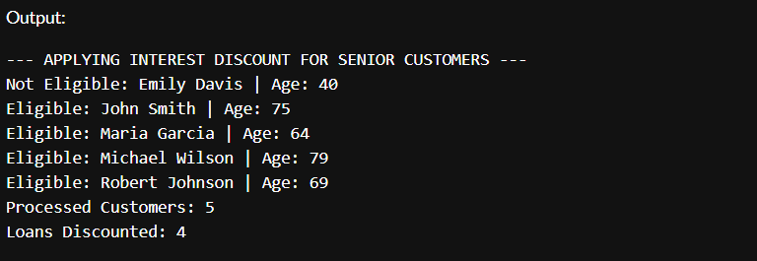

**Scenario 2:**

DECLARE

v_customers_checked NUMBER := 0;

v_promoted_count NUMBER := 0;

v_vip_existing NUMBER := 0;

v_ineligible_customers NUMBER := 0;

CURSOR vip_cursor IS

SELECT customer_id, customer_name, balance, is_vip

FROM customers

ORDER BY balance DESC;

BEGIN

DBMS_OUTPUT.PUT_LINE('--- EVALUATING CUSTOMERS FOR VIP PROMOTION ---');

FOR cust IN vip_cursor LOOP

v_customers_checked := v_customers_checked + 1;

IF cust.balance > 10000 THEN

IF cust.is_vip = 'Y' THEN

v_vip_existing := v_vip_existing + 1;

ELSE

UPDATE customers SET is_vip = 'Y' WHERE customer_id = cust.customer_id;

v_promoted_count := v_promoted_count + 1;

DBMS_OUTPUT.PUT_LINE('Promoted to VIP: ' || cust.customer_name);

END IF;

ELSE

v_ineligible_customers := v_ineligible_customers + 1;

END IF;

END LOOP;

DBMS_OUTPUT.PUT_LINE('Total Evaluated: ' || v_customers_checked);

DBMS_OUTPUT.PUT_LINE('New VIPs: ' || v_promoted_count);

DBMS_OUTPUT.PUT_LINE('Already VIP: ' || v_vip_existing);

DBMS_OUTPUT.PUT_LINE('Not Eligible: ' || v_ineligible_customers);

IF v_promoted_count > 0 THEN

COMMIT;

END IF;

EXCEPTION

WHEN OTHERS THEN

ROLLBACK;

DBMS_OUTPUT.PUT_LINE('Error: ' || SQLERRM);

END;

/

**Output :**

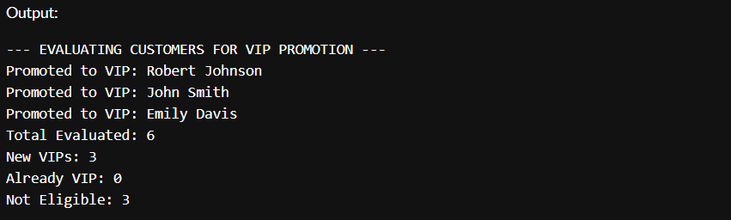

**Scenario 3:**

BEGIN

DBMS_OUTPUT.PUT_LINE('--- REMINDER: Upcoming Loan Dues in Next 30 Days ---');

FOR rec IN (

SELECT l.loan_id, l.customer_id, l.loan_due_date, l.loan_amount,

c.customer_name, c.email, c.phone

FROM loans l

JOIN customers c ON l.customer_id = c.customer_id

WHERE l.loan_status = 'ACTIVE'

AND l.loan_due_date BETWEEN SYSDATE AND (SYSDATE + 30)

ORDER BY l.loan_due_date

) LOOP

DBMS_OUTPUT.PUT_LINE('Reminder for ' || rec.customer_name);

DBMS_OUTPUT.PUT_LINE('-> Loan ID: ' || rec.loan_id ||

', Due Date: ' || TO_CHAR(rec.loan_due_date, 'DD-Mon-YYYY') ||

', Amount: ₹' || TO_CHAR(rec.loan_amount, '999,999.99'));

DBMS_OUTPUT.PUT_LINE('-> Contact: ' || rec.email || ' | ' || rec.phone);

DBMS_OUTPUT.PUT_LINE('--------------------------------------------------');

END LOOP;

EXCEPTION

WHEN OTHERS THEN

DBMS_OUTPUT.PUT_LINE('Error occurred while fetching reminders: ' || SQLERRM);

END;

/

**Output :**

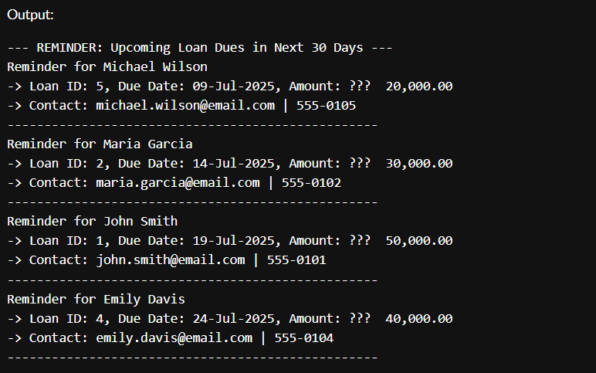

**Exercise 3 : Stored Procedure**

SET SERVEROUTPUT ON SIZE 1000000;

CREATE TABLE customers (

customer_id NUMBER PRIMARY KEY,

customer_name VARCHAR2(100) NOT NULL,

date_of_birth DATE NOT NULL,

balance NUMBER(15,2) DEFAULT 0,

is_vip CHAR(1) DEFAULT 'N' CHECK (is_vip IN ('Y', 'N')),

email VARCHAR2(100),

phone VARCHAR2(15),

created_date DATE DEFAULT SYSDATE

);

CREATE TABLE loans (

loan_id NUMBER PRIMARY KEY,

customer_id NUMBER NOT NULL,

loan_amount NUMBER(15,2) NOT NULL,

interest_rate NUMBER(5,2) NOT NULL,

loan_start_date DATE NOT NULL,

loan_due_date DATE NOT NULL,

loan_status VARCHAR2(20) DEFAULT 'ACTIVE',

CONSTRAINT fk_customer_loan FOREIGN KEY (customer_id) REFERENCES customers(customer_id)

);

CREATE SEQUENCE customer_seq START WITH 1 INCREMENT BY 1;

CREATE SEQUENCE loan_seq START WITH 1 INCREMENT BY 1;

INSERT INTO customers (customer_id, customer_name, date_of_birth, balance, email, phone) VALUES

(customer_seq.NEXTVAL, 'Vikram Shah', DATE '1951-04-20', 16400.00, 'vikram.shah@email.com', '999-1211');

INSERT INTO customers (customer_id, customer_name, date_of_birth, balance, email, phone) VALUES

(customer_seq.NEXTVAL, 'Rina Dutta', DATE '1961-07-14', 8100.00, 'rina.dutta@email.com', '999-1212');

INSERT INTO customers (customer_id, customer_name, date_of_birth, balance, email, phone) VALUES

(customer_seq.NEXTVAL, 'Karthik Rao', DATE '1954-01-25', 23400.00, 'karthik.rao@email.com', '999-1213');

INSERT INTO customers (customer_id, customer_name, date_of_birth, balance, email, phone) VALUES

(customer_seq.NEXTVAL, 'Neha Pillai', DATE '1988-02-28', 13800.00, 'neha.pillai@email.com', '999-1214');

INSERT INTO customers (customer_id, customer_name, date_of_birth, balance, email, phone) VALUES

(customer_seq.NEXTVAL, 'Manoj Kapoor', DATE '1946-09-03', 5100.00, 'manoj.kapoor@email.com', '999-1215');

INSERT INTO customers (customer_id, customer_name, date_of_birth, balance, email, phone) VALUES

(customer_seq.NEXTVAL, 'Swathi Balan', DATE '1991-12-12', 7600.00, 'swathi.balan@email.com', '999-1216');

INSERT INTO loans (loan_id, customer_id, loan_amount, interest_rate, loan_start_date, loan_due_date) VALUES

(loan_seq.NEXTVAL, 1, 41000.00, 5.4, DATE '2024-01-20', SYSDATE + 17);

INSERT INTO loans (loan_id, customer_id, loan_amount, interest_rate, loan_start_date, loan_due_date) VALUES

(loan_seq.NEXTVAL, 2, 28000.00, 5.9, DATE '2024-03-15', SYSDATE + 14);

INSERT INTO loans (loan_id, customer_id, loan_amount, interest_rate, loan_start_date, loan_due_date) VALUES

(loan_seq.NEXTVAL, 3, 72000.00, 4.9, DATE '2024-02-18', SYSDATE + 41);

INSERT INTO loans (loan_id, customer_id, loan_amount, interest_rate, loan_start_date, loan_due_date) VALUES

(loan_seq.NEXTVAL, 4, 37500.00, 5.3, DATE '2024-05-02', SYSDATE + 21);

INSERT INTO loans (loan_id, customer_id, loan_amount, interest_rate, loan_start_date, loan_due_date) VALUES

(loan_seq.NEXTVAL, 5, 19500.00, 6.2, DATE '2024-04-10', SYSDATE + 11);

CREATE TABLE employees (

employee_id NUMBER PRIMARY KEY,

employee_name VARCHAR2(100),

department_id NUMBER,

salary NUMBER(10,2)

);

CREATE TABLE accounts (

account_id NUMBER PRIMARY KEY,

customer_id NUMBER,

balance NUMBER(15,2)

);

INSERT INTO employees VALUES (21, 'Aakash Mehta', 15, 48000);

INSERT INTO employees VALUES (22, 'Bhavna Reddy', 15, 45500);

INSERT INTO employees VALUES (23, 'Harsh Soni', 25, 59500);

INSERT INTO accounts VALUES (3001, 1, 3200);

INSERT INTO accounts VALUES (3002, 2, 1500);

COMMIT;

CREATE OR REPLACE PROCEDURE ProcessMonthlyInterest AS

BEGIN

UPDATE customers

SET balance = balance + (balance * 0.01)

WHERE balance > 0;

DBMS_OUTPUT.PUT_LINE('Monthly interest of 1% applied to all savings accounts.');

COMMIT;

END;

/

CREATE OR REPLACE PROCEDURE UpdateEmployeeBonus (

p_dept_id IN NUMBER,

p_bonus_percent IN NUMBER

) AS

BEGIN

UPDATE employees

SET salary = salary + (salary * p_bonus_percent / 100)

WHERE department_id = p_dept_id;

DBMS_OUTPUT.PUT_LINE('Bonus of ' || p_bonus_percent || '% applied to department ' || p_dept_id);

COMMIT;

END;

/

CREATE OR REPLACE PROCEDURE TransferFunds(

p_from_account IN NUMBER,

p_to_account IN NUMBER,

p_amount IN NUMBER

) AS

v_balance NUMBER;

BEGIN

SELECT balance INTO v_balance FROM accounts WHERE account_id = p_from_account FOR UPDATE;

IF v_balance < p_amount THEN

RAISE_APPLICATION_ERROR(-20001, 'Insufficient funds in source account.');

END IF;

UPDATE accounts SET balance = balance - p_amount WHERE account_id = p_from_account;

UPDATE accounts SET balance = balance + p_amount WHERE account_id = p_to_account;

DBMS_OUTPUT.PUT_LINE('Transferred ' || p_amount || ' from account ' || p_from_account || ' to account ' || p_to_account);

COMMIT;

END;

/